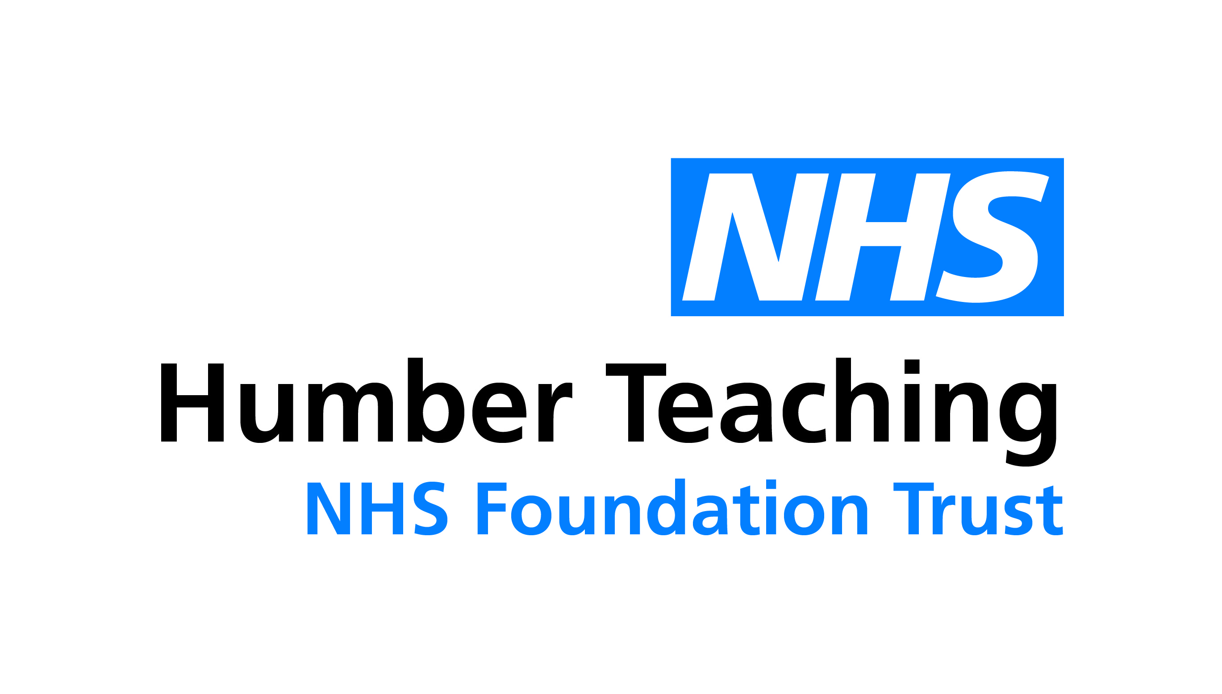**Development**

**Guidance Notes**

Bringing our values to life: Caring, Learning, Growing

**How do I develop myself or a member of my team?** There are lots of different tools and methods that we can use to learn a new skill or develop and improve an existing skill. During appraisals, we are asked to focus on our development, and this guidance will provide just a snapshot of different approaches that you can take.

**Attend a face to face course** this is probably one of the first options that we think of when we think of development. Take a look at the options available to you internally on ESR. If you think you need to attend an external learning event, this will need to be discussed with your line manager.

**Sign up to an online learning course** there are a whole range of online learning events that you can sign up to now, both internally on ESR, within the NHS, and externally. Most of these are relatively low cost, and can be done at a time convenient to you.

**Journals and blogs** keeping your knowledge updated is a constant challenge. By reading appropriate journals, professional magazines and blogs you can yourself up to date with the latest practices and thinking, or expand your awareness of new areas.

**Coaching** a coach can help you to explore options available to you, help you to recognise where opportunities exist, and where you need to focus some attention to improve. Generally they will work with you over a set time frame to help you to focus on what you want, and help you to define what you need to do to achieve it.

**Mentoring** a mentor is slightly different from a coach in that they can offer you direct advice as they know the subject area that you are working in. Often a mentor is someone more senior to you, who can help to guide you and your career towards where you aspire to be.

**Shadowing** this is where you work with someone who is doing the role that you want to do. By working with them you can learn first-hand what is involved in the job, and have someone more experienced next to you to support you. This is really useful when people are new to role, or new to the Trust.

**Get involved with a Project or working group** working on a project that is outside of your team can really help to grow your skills as you get to experience work that is outside of your normal role. You can make contacts with more people, and look issues and challenges from a different perspective.

**Videos** there are a whole range of different video content available on the internet to help with self-development. YouTube and TedTalks are a really good place to start to explore these options.

**Podcasts** as with videos, Podcasts are a great way to help you to expand your knowledge, even when you are doing something else.

**Attend professional meetings / events** attending meetings, even if you don’t contribute, is a really good way of growing your knowledge and awareness of a subject as you listen to what others discuss. It can provide you with different viewpoints, and help you to recognise some of the challenges when implementing new practices and policies.

**Ask for feedback** often we are unaware of how others see us, or where the gaps exist in our own knowledge. Asking for feedback, and taking on board what is said to us, is a really key way to help us to see where and sometimes even how we can improve.

**Self-evaluation tests** there are a whole range of different tests that you can access both on-line and on the intranet to help us to learn a little more about ourselves, where we are strong, and where we have areas that could be improved. These can be in areas such as how we work in a team, our communication preferences, how we are in social situations and what our leadership styles are.

**Distance learning** many colleges and universities now offer a whole range of distance learning programmes that we can complete at a time that is convenient to us. Materials are often sent through the post, or email to you to work through independently at your own pace. There is often a tutor who you can access for help.

**Support others to develop** becoming a mentor or a coach for someone else is also a really good way to help you to improve as to support others development. You have to really think about what you are doing and the best way to describe it. You will often find that someone new to the role will have new ideas and challenge you to think about things differently.